Chapter 15, Solution 57.

Although there is no correct way to work this problem, this is an example based on the same kind of problem asked in the third edition.

Problem

Solve the following integrodifferential equation using the Laplace transform method:

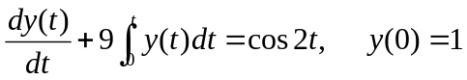

Solution

Take the Laplace transform of each term.

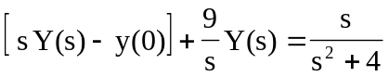

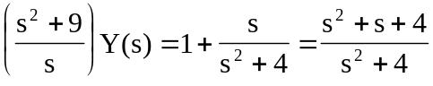

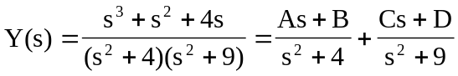

Equating coefficients :
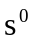: 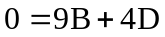
: 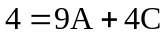
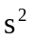: 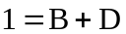
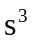: 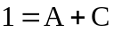

Solving these equations gives

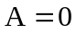, 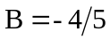, 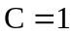, 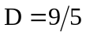

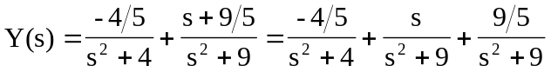

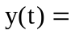[]u(t)

